ASSIGNMENT-4

NAME | R.VINOTHINI RAJAM
TEAM ID | PNT2022TMID51128
PROJECT NAME | IoT based Safety Gadget for Child Safety Monitoring and Notification

Coding:

#include <WiFi.h>
#include <PubSubClient.h>
WiFiClient wifiClient;
String data3;
#define ORG "qe3gb4"
#define DEVICE_TYPE "51128-80"
#define DEVICE_ID "Vinothini-device"
#define TOKEN "P?7NR3H!J36GewHgIO"
#define speed 0.034
#define led 14
char server[] = ORG ".messaging.internetofthings.ibmcloud.com";
char publishTopic[] = "iot-2/evt/Data/fmt/json";
char topic[] = "iot-2/cmd/led/fmt/String";
char authMethod[] = "use-token-auth";
char token[] = TOKEN;
char clientId[] = "d:" ORG ":" DEVICE_TYPE ":" DEVICE_ID;
PubSubClient client(server, 1883, wifiClient);

const int trigpin=5;
const int echopin=18;
String command;
String data="";

long duration;
float dist;

void setup()
{
Serial.begin(115200);
pinMode(led, OUTPUT);
pinMode(trigpin, OUTPUT);
pinMode(echopin, INPUT);
wifiConnect();
mqttConnect();
}

void loop() {
bool isNearby = dist < 100;
digitalWrite(led, isNearby);

publishData();
delay(500);

if (!client.loop()) {
mqttConnect();
}
}

void wifiConnect() {
Serial.print("Connecting to "); Serial.print("Wifi");
WiFi.begin("Wokwi-GUEST", "", 6);
while (WiFi.status() != WL_CONNECTED) {
delay(500);
Serial.print(".");
}
Serial.print("WiFi connected, IP address: "); Serial.println(WiFi.localIP());
}

void mqttConnect() {
if (!client.connected()) {
Serial.print("Reconnecting MQTT client to "); Serial.println(server);
while (!client.connect(clientId, authMethod, token)) {
Serial.print(".");
delay(500);
}
initManagedDevice();
Serial.println();
}
}

void initManagedDevice() {
if (client.subscribe(topic)) {
// Serial.println(client.subscribe(topic));
Serial.println("IBM subscribe to cmd OK");
} else {
Serial.println("subscribe to cmd FAILED");
}
}
void publishData()
{
digitalWrite(trigpin,LOW);
digitalWrite(trigpin,HIGH);
delayMicroseconds(10);
digitalWrite(trigpin,LOW);
duration=pulseIn(echopin,HIGH);
dist=duration*speed/2;
if(dist<100){
String payload = "{\"Alert Distance\":";
payload += dist;
payload += "}";

Serial.print("\n");
Serial.print("Sending payload: ");
Serial.println(payload);
if (client.publish(publishTopic, (char*) payload.c_str())) {
Serial.println("Publish OK");
}

}
if(dist>100){
String payload = "{\"Distance\":";
payload += dist;
payload += "}";

Serial.print("\n");
Serial.print("Sending payload: ");
Serial.println(payload);
if(client.publish(publishTopic, (char*) payload.c_str())) {
Serial.println("Publish OK");
}else {
Serial.println("Publish FAILED");
}

}

}
CONNECTIONS:

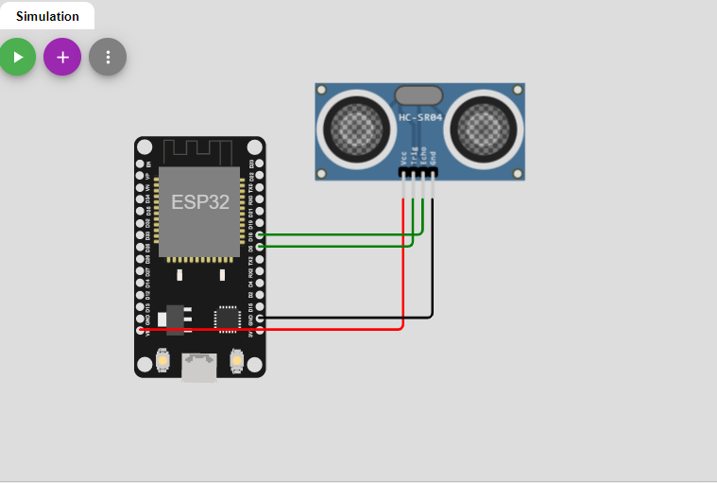

OUTPUT:

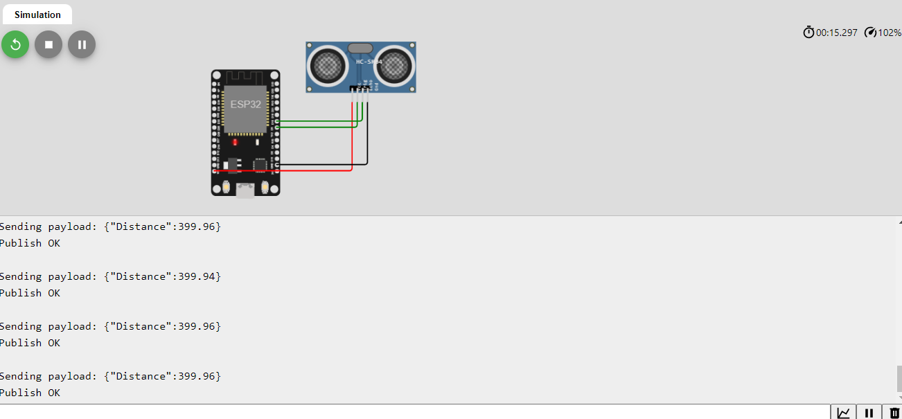
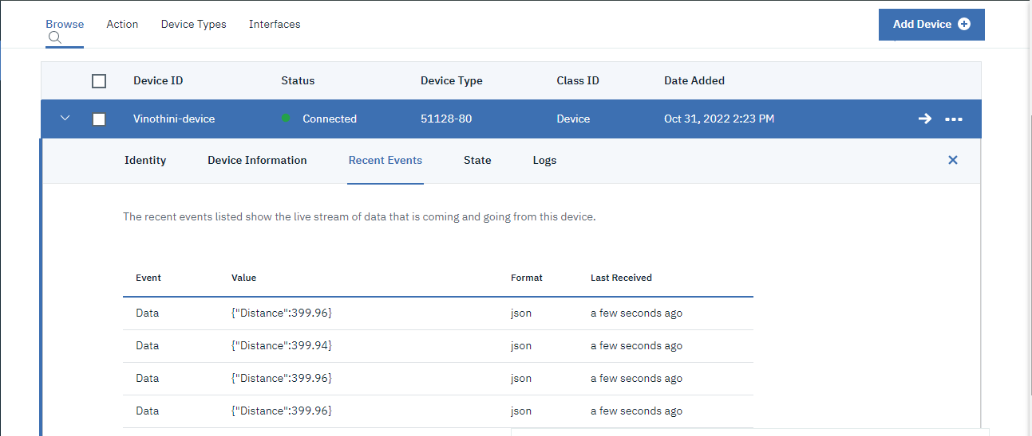

WOKWI LINK:

https://wokwi.com/projects/347026760345322067

